Suryanarayan.B

CB.EN.U4CSE19056

VLan

Vlan10

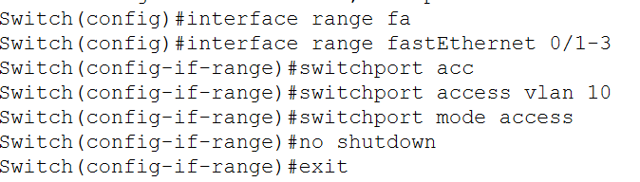

Vlan20

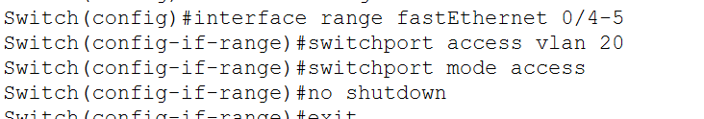

Vlan30

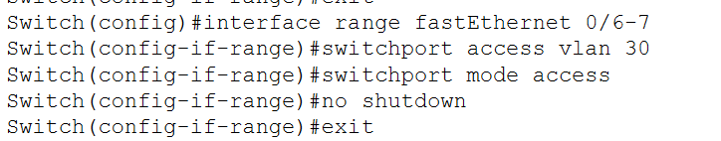

Vlan40

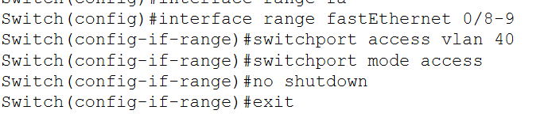

Vlan50

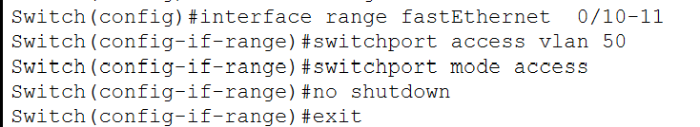

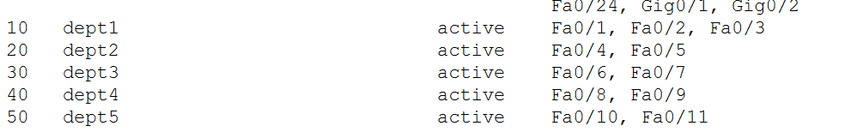

Router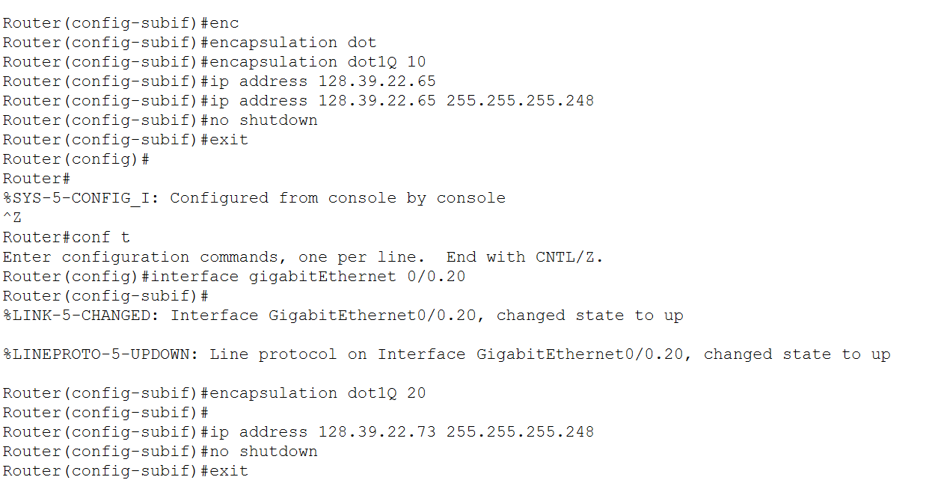

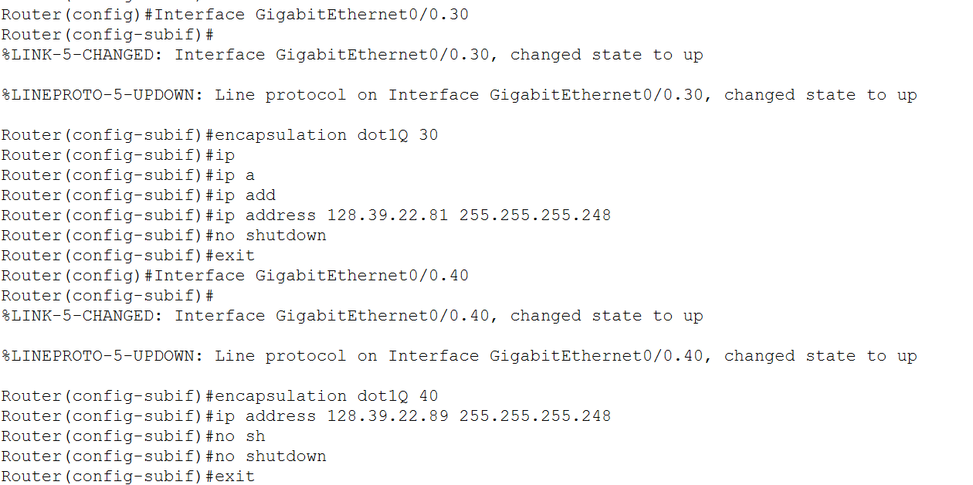

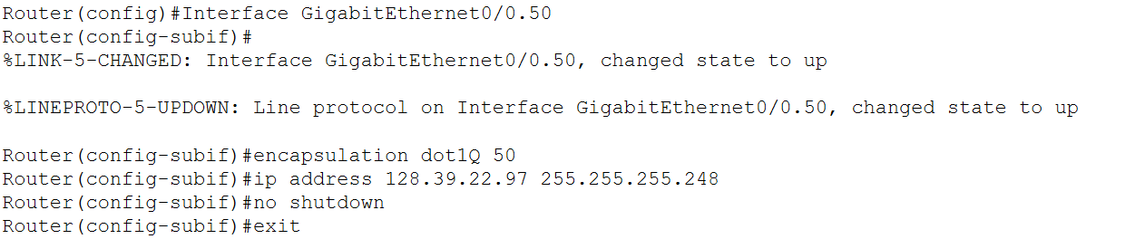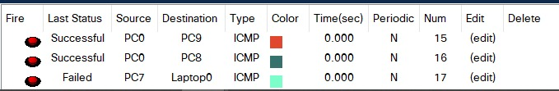

RIP:

